CODING CONTEST-2 DATE : 19th April 2023

**PART-A:**

import org.openqa.selenium.By;

import org.openqa.selenium.WebDriver;

import org.openqa.selenium.chrome.ChromeDriver;

import org.openqa.selenium.chrome.ChromeOptions;

import org.testng.annotations.Test;

import io.github.bonigarcia.wdm.WebDriverManager;

public class d7new {

@Test

public void f() {

WebDriverManager.chromedriver().setup();

WebDriver driver;

ChromeOptions co = new ChromeOptions();

co.addArguments("--remote-allow-origins=*");

driver=new ChromeDriver(co);

driver.get("https://www.yatra.com/flights");

driver.manage().window().maximize();

driver.findElement(By.xpath("//*[@id=\"booking_engine_flights\"]/div/span")).click();

driver.findElement(By.xpath("//*[@id=\"BE_flight_form_wrapper\"]/div[1]/div[1]/ul[1]/li[2]/a")).click();

}

}

**OUTPUT(SCREENSHOTS)**

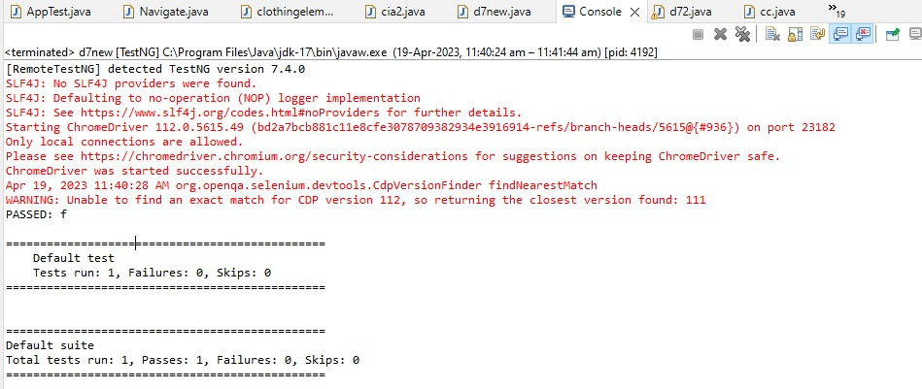

**PART-B:**

**import org.openqa.selenium.By;**

**import org.openqa.selenium.WebDriver;**

**import org.openqa.selenium.chrome.ChromeDriver;**

**import org.openqa.selenium.chrome.ChromeOptions;**

**import org.testng.annotations.Test;**

**import io.github.bonigarcia.wdm.WebDriverManager;**

**public class d7new {**

**@Test**

**public void f() {**

**WebDriverManager.chromedriver().setup();**

**WebDriver driver;**

**ChromeOptions co = new ChromeOptions();**

**co.addArguments("--remote-allow-origins=*");**

**driver=new ChromeDriver(co);**

**driver.get("https://www.yatra.com/flights");**

**driver.manage().window().maximize();**

**driver.findElement(By.xpath("//*[@id=\"booking_engine_flights\"]/div/span")).click();**

**driver.findElement(By.xpath("//*[@id=\"BE_flight_form_wrapper\"]/div[1]/div[1]/ul[1]/li[2]/a")).click();**

**}**

**}**

**OUTPUT(SCREENSHOTS)**

